**6-YOUR CHILD YOU CAN FIND THE FOLLOWING ADVICE:**

**5- Act consciously.**

**Safe Internet Day**

**Parent Brochure**

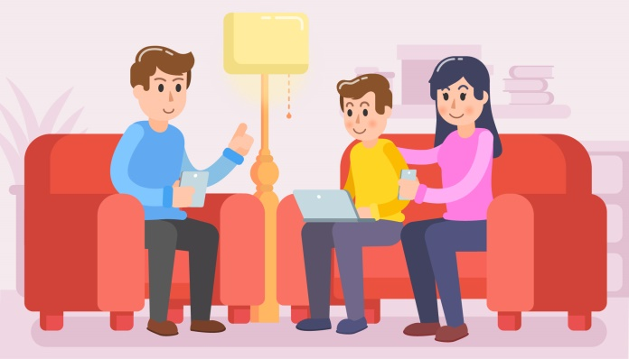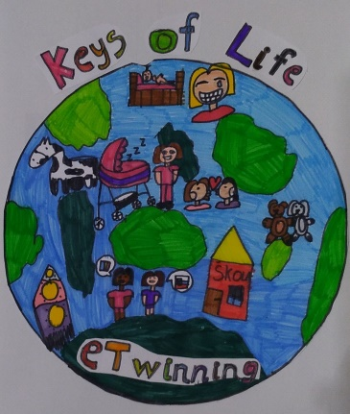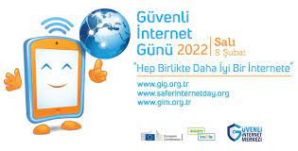

1. You should not respond to unpleasant messages and emails.

2. You should not open messages and e-mails from people you do not know; You should not click on links.

3. Unpleasant messages, e-mails from a person or people you know or do not know

When you receive it, you should block the person, tell me or your teacher.

4. Anybody ask you to provide personal information about yourself If he insists on sharing, you should let me know.

5. You should create secure passwords and not share them with anyone.

6. People behave differently online or hide themselvesit could be. For this reason, you should not make virtual contact with people you do not know.

7.You must notify me before downloading any content.

• Digital technologies and their conversations about the effects keep doing it.

• Risks and possible about security measures Talk to your child help be conscious do it. 'Cause he's always on top You cannot. Your aim is to the child raise awareness should be.

• Critical to your child teach to think.

• Your child is safe and trusted websites and in determining applications help me. Contents when clicking, downloading, when uploading and posting about being careful encourage them.

As a good parent to our children; crossing the streetto look both ways, swimming, cycling if we are teaching.

Digital safe in the world for them to roam; information communication tools and the Internet learning how to use them safely they need it.